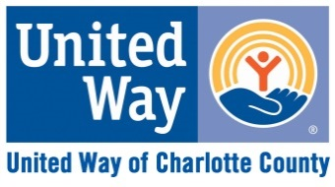
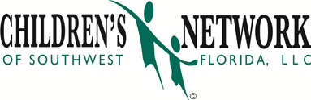

MENTORING FOR SUCCESS
Volunteers Needed To Help Charlotte County Families
MENTOR A FAMILY TODAY!
VISITING A FAMILY FOR JUST ONE HOUR A WEEK CAN HELP PARENTS REACH THEIR GOALS!
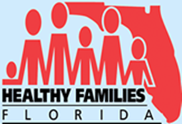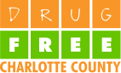

Register Now: Mentor Training Class Starts Soon! To register or for more information contact Mentor Coordinator: Pamela Malik 941-613-3937 or pmalik@cnswfl.org
Children’s Network of Southwest Florida, Inc.

(941) 613-3937 | fax (941) 613-3800 | 19621 Cochran Blvd Unit 4 | Port Charlotte, FL 33948

The Children’s Network of Southwest Florida is sponsored in part by the State of Florida, Department of Children and Families

The Children’s Network of Southwest Florida is committed to working with the community to protect children and preserve families.

